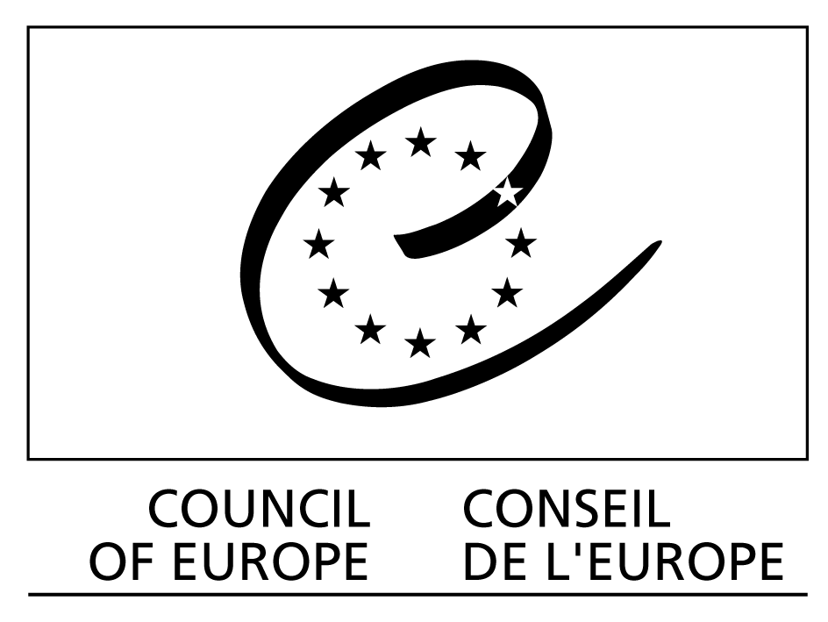
The Council of Europe at the Internet Governance Forum
(12-15 November 2007, Rio de Janeiro, Brazil)

Main sessions

Monday 12 November 2007

Opening ceremony
11 am-1 pm, Room Segovia
Maud de Boer-Buquicchio, Deputy Secretary General of the Council of Europe, addresses the opening ceremony.

Wednesday 14 November 2007

Main session: Openness
11 am-1 pm, Room Segovia
Council of Europe experts involved as panellists: Mark Kelly (Ireland)

Main session: Security
4 pm-6 pm, Room Segovia
Council of Europe experts involved as panellists: Marco Gercke (Germany)

COUNCIL OF EUROPE EVENTS

Monday 12 November 2007

Workshop: Freedom of expression as a security issue
1.30 pm-3 pm, Room Versailles II
Organised by: Council of Europe / UNESCO / OSCE
Council of Europe experts involved as key speakers: Karol Jakubowicz (Poland)
Council of Europe experts involved as participants: Mark Kelly (Ireland),Matthias Traimer (Austria), Yves Poullet (Belgium), Marco Gercke (Germany) and Denton Howard (INHOPE)

Open forum: Protecting children on the Internet
3.30 pm-5 pm, Room Versailles II
Council of Europe experts/speakers: Deputy Secretary General Maud de Boer-Buquicchio, David Reid (BBC), Ana Mee Ertzeid (Norway), Mark Kelly (Ireland), Matthias Traimer (Austria), Karol Jakubowicz (Poland), Divina Frau-Meigs (France)
Confirmed participants: Stephen Balkam (Family Online Safety Institute), Senator Azeredo (Brazil), Dr Niels J. Seeberg-Elverfedt (Germany) and representative of ECPAT

Best Practice Forum: Public participation in Internet Governance: Emerging Issues, good practices and proposed solutions
5.30 pm-7 pm, Room Alhambra II
Organised by: Council of Europe / United Nations Economic Commission for Europe / Association for Progressive Communications (APC)
Council of Europe experts involved as key speakers: Deputy Secretary General and Michael Remmert (Council of Europe Secretariat)

Tuesday 13 November 2007

Best Practice Forum: Cybercrime Convention
8.30 am-10 am, Room Versailles II
Council of Europe experts involved as key speakers: Marco Gercke (Germany), Senator Azeredo (Brazil) and Mr Velasquez (Mexico)

Workshop: Content regulation and the duty of states to protect fundamental rights
12.30 pm-2 pm, Room Versailles II
Organised by: Association for Progressive Communications (APC) WNSP: Civil Society / Council of Europe / EuroISPA: Private, Pan-European association of Internet services providers
Council of Europe experts involved as key speakers: Matthias Traimer (Austria) and Mark Kelly (Ireland)
Council of Europe experts involved as confirmed participants: Karol Jakubowicz (Poland)

Workshop: 'Quality' and the Internet: using and trusting internet content
2.30 pm-4 pm, Room Versailles II
Organised by: Council of Europe / WBU / BBC / IFJ
Council of Europe experts involved as key speakers: Karol Jakubowicz (Poland)
Council of Europe experts involved as confirmed participants: Mark Kelly (Ireland), Matthias Traimer (Austria) and Divina Frau Meigs (France)

Open Forum: Public service value of the Internet
4.30 pm-6 pm, Room Pardo II
Council of Europe experts involved as key speakers: Karol Jakubowicz (Poland), Matthias Traimer (Austria), Ana-Mee Ertzeid (Norway), Giacomo Mazzone (EBU), Divina Frau Meigs (France), Mark Kelly (Ireland), Yves Poullet (Belgium), Marco Gercke (Germany) and Denton Howard (INHOPE)

Wednesday 14 November 2007

Workshop: Legislative responses to current and future cyber-threats
10.30 am-12 pm, Room Alhambra II
Organised by: Council of Europe / Cyberlaw Asia
Council of Europe key speakers: Marco Gercke (Germany), Denton Howard (INHOPE), Pavan Duggal (India), Senator Azeredo (Brazil), Zahid Jamil (Pakistan) and Yves Poullet (Belgium)

