|  |  |  |
| --- | --- | --- |
|  | ***EEA Grant and Norway grants (2)*** | COE-Logo-Quadri |

**THE HATE FACTOR IN POLITICAL SPEECH**

***Where do responsibilities lie?***

**18-19 September 2013**

**Airport Hotel Okęcie, Warsaw**

# Speakers’ profiles

# Opening session

**Mr Michał Boni**, Minister of Administration and Digitization of Poland, Chairman of the Conference

Mr Michał Boni 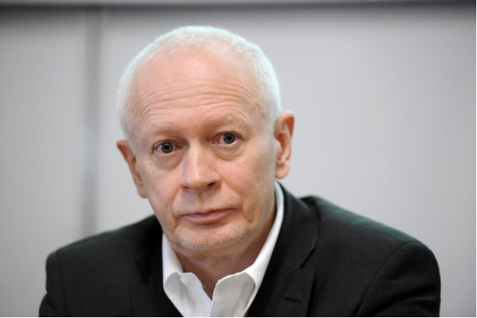was born in 1954 in Poznan, a graduate of the University of Warsaw, where for many years he lectured in the Department of Polish Culture. He was involved in "Solidarity" movement since 1980, since 1989 a member of the national authorities of "Solidarity", in 1990 – chairman of the "Mazowsze" Region Managing Board.

In 1991, he was the Minister of Labour and Social Policy, from 1992 to 1993 he held the position of the Secretary of State in the same ministry, where he was responsible, inter alia, for labour market policy. He was a Member of Parliament of the first tenure. Since 1995, he has been the director of the Social Policy Reform Program at the Stefan Batory Foundation. He was Councillor of Centrum Commune of the municipal city of Warsaw in 1994-1996. From 1996 to 1997, he was the Director and Member of the Institute of Public Affairs. From 1998 to 2001, he was the chief advisor to the Minister of Labour and Social Policy.

In 2007, he was enterprise investors’ consultant in the field of human resource management and since 1994 member of the Scientific Committee of the Community Support Framework for the Evaluation of the National Development Programme and Operational Programmes. He was key expert cooperating in shaping of the National Development Plan and the National Action Plan for 2007-2013. In 2007, he was Lewiatan (Polish Confederation of Private Employers) advisor. Since January 2008, he has been the Secretary of State in the Prime Minister's Office. He is one of the authors of the "Solidarity across generations 50+", which is designed to help people over 50 return to the labour market.

In 2009 appointed to the office of the Minister – a member of the Council of Ministers and Chairman of the Standing Committee of the Council of Ministers. Since 2008 he was the Head of Strategic Advisors to the Prime Minister. Under his leadership the team has conducted a socio-economic evaluation of Poland and has participated in the development of strategic plans of the government. Among some of the most important documents are: "Report on Polish Intellectual Capital", "Returner; Navigation for returning migrants", "Poland 2030; and Development Challenges" and "Youth 2011".

Since 18.11.2011 he has sworn in as the Minister of Administration and Digitization.

**Mr Thorbjørn Jagland**, Secretary General of the Council of Europe

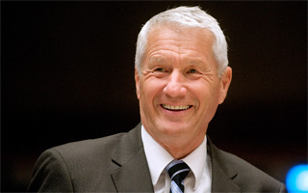Mr Thorbjørn Jagland is Secretary General of the Council of Europe since 1 October 2009. He was the President of the Storting (Norwegian Parliament) from 2005 to 2009.

He was elected Chairman of the Norwegian Nobel Committee, which awards the Nobel Peace Prize every year. He has held two of the most influential governmental positions in Norway: Prime Minister (1996-97) and Minister of Foreign Affairs (2000-2001).

After serving as Foreign Minister, he was Chairman of the Standing Committee on Foreign Affairs and the enlarged Foreign Affairs Committee in the Storting for four years (2001-2005). He also served as Chairman of the EEA Consultative Committee during this period (2000-2005).

In addition, he has held a number of other parliamentary positions, such as head of the Storting's Delegation for Relations with the European Parliament for six years. He was a member of the Storting for 15 years.

Mr Jagland was Leader of the Norwegian Labour Party for ten years (1992-2002), and Party Secretary of the Labour Party for five years (1987-1992).

He is currently the Chairman of the Board of Directors at the Oslo centre for Peace and Human Rights, and Member of the International Board of Governors at the Peres Center for Peace. He served as Vice-President of the Socialist International 1999-2008, and Chair of the Social International Middle East Committee from 2000 to 2006. He was a member of the Sharm El-Sheikh Fact-finding Commission (The Mitchell Commission) from 2000 to 2001.

Over the last 20 years, Mr Jagland has published widely on a range of issues, in particular on European and international affairs. He has published four books in Norway: My European Dream (1990), Letters (1995), Our Vulnerable World (2001) and Ten Theses on the EU and Norway (2003). He holds a degree in Economics from the University of Oslo (1975).

He was born on 5 November 1950 in Drammen, Norway. He is married to Hanne Grotjord. They have two children.

# Keynote

**Ingrid Schulerud**, Ambassador, Section for Central Europe and EEA/Norway Grants in the Norwegian Ministry of Foreign Affairs

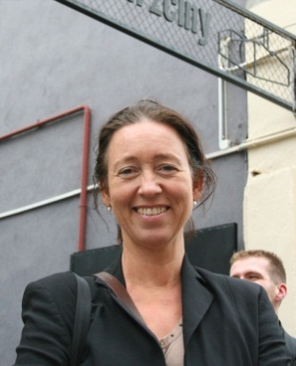Ms Schulerud is currently responsible for overall policy planning and strategic dialogue with the 15 Beneficiary States under the EEA and Norway Grants. The current granting period has a total budget of 1.78 billion Euros. Ms Schulerud has since 1989 worked in the Ministry with responsibilities connected to the Baltic States and Central Europe, bilateral relations, human rights, civil society funding and good governance issues.

# Session 1 European legal standards on hate speech – is there an acquis?

**Mr Tarlach McGonagle**, Senior researcher, Institute for Information Law, University of Amsterdam f

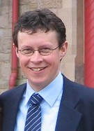Tarlach McGonagle specialises in a broad range of topics relating to international and European human rights law, especially the rights to freedom of expression and religion, minority rights, participatory rights, and cultural and linguistic rights. His other main area of expertise is international, European and comparative media law and policy. Themes such as pluralism, diversity, tolerance and “hate speech” have a central place in his research. He was awarded a Ph.D. by the University of Amsterdam (2008) for his thesis examining the interface between freedom of expression and minority rights under international law. He also holds an LL.M. degree in International Human Rights Law (University of Essex, 2001) and a B.A. International in Law and French (National University of Ireland, Galway, 1998). He regularly writes expert reports for various branches of the Council of Europe, OSCE and other IGOs and NGOs. He was an invited expert speaker at the Thematic Discussion on “Racist Hate Speech” organised by the United Nations Committee on the Elimination of Racial Discrimination in 2012. In spring 2013, he was a Visiting Scholar at the Centre for Global Communication Studies (CGCS), Annenberg School for Communication, University of Pennsylvania and a Visiting Fellow at the Rutgers Institute for Information Policy and Law (RIIPL), Rutgers School of Law - Camden, New Jersey. He is an associate member of the (Netherlands) School of Human Rights Research. He is also a member of the Editorial Board of the European Audiovisual Observatory. He is Coordinator of IViR's specialised masters programme, Informatierecht, and he coordinates and lectures on a number of the programme's compulsory and elective modules, and is the programme's dissertations coordinator.

**Ms Françoise Tulkens**, former Judge and Vice-President of the European Court of Human Rights

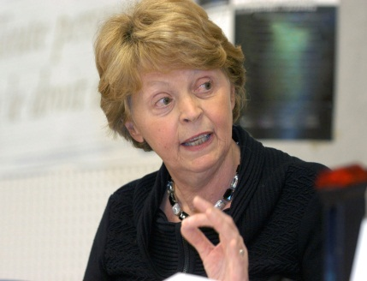Françoise Tulkens has a Doctorate in Law, a Master’s degree in Criminology and a Higher education teaching certificate (*agrégation de l’enseignement supérieur*) in Law. She was a Professor at the University of Louvain (Belgium) and has taught, in Belgium as well as abroad – as a visiting professor at the Universities of Geneva, Leuven, Ottawa, Paris I, Rennes, Strasbourg and Louisiana State University – in the fields of general criminal law, comparative and European criminal law, juvenile justice and human rights protection systems. She has authored many publications in the areas of human rights and criminal law. She holds honorary doctorates from the Universities of Geneva, Limoges, Ottawa and Ghent. From November 1998 to September 2012, she was a Judge in the European Court of Human Rights, serving as Section President from January 2007 and as Vice-President of the Court from February 2011. She has been an Associate Member of the Belgian Royal Academy since 2011. In September 2012, she took up an appointment as a member of the Kosovo Human Rights Advisory Panel.

**Mr Morten Kjaerum,** Director, European Union Agency for Fundamental Rights (FRA)

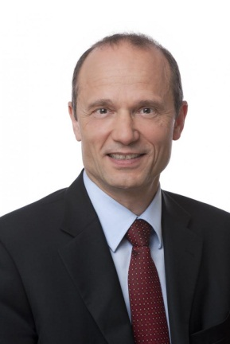Morten Kjaerum was appointed as Director of the FRA in 2008 for a period of five years. On 22 May 2013, FRA’s Management Board formally decided to extend his contract as Director for another three years, with effect from 1 June 2013.

Before joining the FRA, Mr Kjaerum served as the founding Director of the Danish Institute for Human Rights. Over 17 years in top executive roles, Mr Kjaerum built the Institute, Denmark’s national human rights institution, into an internationally recognised institution.

An expert in human rights, Mr Kjaerum has been a member of the United Nations Committee on the Elimination of Racial Discrimination and the President of the International Coordination Committee for National Human Rights Institutions, a network coordinating relations between the United Nations and national institutions.

Mr Kjaerum has written extensively on issues relating to human rights, in particular on refugee law, the prohibition against racial discrimination, and the role of national human rights institutions. He is honorary professor at the University of Aalborg.

**Mr Kerem Altiparmak,** Director of Human Rights Centre, Faculty of Political Sciences, Ankara University.

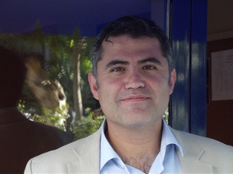Kerem Altiparmak is the Director of Human Rights Centre of the Faculty of Political Sciences at Ankara University. He is teaching human rights law both at graduate and post-graduate level. He has also worked in a number of human rights projects with human rights NGOs in Turkey. He is currently working with the Human Rights Joint Platform in two projects: “Monitoring of the Implementation of the ECtHR Judgments in Turkey” and “From Impunity to Accountability”.

His research interests include the European Convention on Human Rights, freedom of expression, prohibition of torture, theories of rights and impunity. He has widely published in Turkish and English.

His English publications include: "The European System for the Protection of Human Rights in Crisis: The End of the Road?" (2009); "Human Rights Act: Extra-territorial Application", (2008); “Internet: Restricted Access - A Critical Assessment of Internet Content Regulation and Censorship in Turkey” (with Yaman Akdeniz); "After Şahin: The Debate on Headscarves is Not Over", (with Onur Karahanoğulları) (2006); “Bankovic: An Obstacle to the Application of the European Convention on Human Rights in Iraq?” (2004); and "The Application of the Concept of Continuing Violation to the Duty to Investigate, Prosecute and Punish under International Human Rights Law"(2003).

# Session 2 Pluralist democracy, populism and political calculus

**Mr Robert Biedroń**, Member of the Polish Parliament, member of the Parliamentary Assembly of the Council of Europe

Robert Biedron is a member of the Polish Parliament and one of the founders and key leaders of the Campaign Against Homophobia in Poland. This group has been one of the most successful LGBT rights groups in the former Soviet Union and has developed strong advocacy and community mobilisation approaches despite a very conservative political context at the national level. Mr. Biedron has been one of the key thinkers behind the success of the group. He also has a strong background in human rights and is well respected within the broader Polish civil society and human rights movements. He is a member of the Advisory Board of Human Rights Initiative of Open Society Foundations. Mr. Biedron received a master of science from Warmia and Mazuria University in Poland, and is currently pursuing a PhD at the Humanistic Academy in Poland.

In October 2011 during parliamentary elections Robert Biedron was elected to the Sejm of the Republic of Poland as an independent candidate of Palikot’s Movement, receiving almost 17 000 votes in Gdynia-Slupsk constituency. He is a vice-president of Palikot’s Movement’s Parliamentary Club. Mr. Biedron is a vice-president of the Commission of Justice and Human Rights and a member of the Commission of Foreign Affairs. He also belongs to many parliamentary groups i.e. Parliamentary Group for Africa and Pomeranian Parliamentary Group. Mr. Biedron is a member of Polish delegation to the Parliamentary Assembly of the Council of Europe.

**Mr Boriss Cilevičs**, Deputy, Saeima of the Republic of Latvia, member of the Parliamentary Assembly of the Council of Europe.

Boriss Cilevičs is a [Latvian](http://en.wikipedia.org/wiki/Latvia) [politician](http://en.wikipedia.org/wiki/Politician).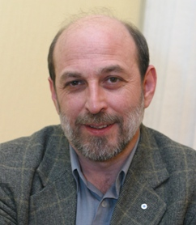 He was born in [Daugavpils](http://en.wikipedia.org/wiki/Daugavpils). He is a member of the [Concord Centre (Social Democratic)](http://en.wikipedia.org/wiki/Harmony_Centre) party and a [deputy](http://en.wikipedia.org/wiki/Deputies_of_the_Saeima) of the [Saeima](http://en.wikipedia.org/wiki/Saeima) (Latvian Parliament). He serves as a member of parliament since 1998. In May–July 2004 he served as Member of the European Parliament.

**Ms Floriane Hohenberg**, Head of the Tolerance and Non-Discrimination Department, Office for Democratic Institutions and Human Rights

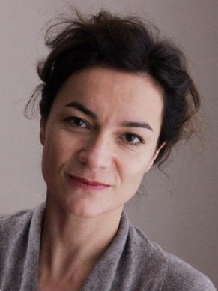Floriane Hohenberg has been working for OSCE/ODIHR since 2005. She has acted as the Head of the Tolerance and Non-Discrimination Department since 2009. From 2000 until 2004 she was the Head of the Berlin Office of the Commission for the Compensation of Victims of Spoliation Resulting from the Anti-Semitic Legislation in Force during the Occupation in France. She co-authored a study commissioned by the French government on the extent of the confiscation of Jewish assets in France during World War II published in 1999.

**Mr Marley Morris**, researcher, Counterpoint, London

[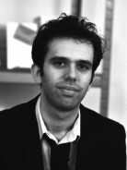](http://counterpoint.uk.com/about-us/#4)Marley Morris is a researcher at Counterpoint, a London-based research and advisory group. Marley works on a number of Counterpoint's projects on populism across Europe, and is co-author of the report 'Recapturing the Reluctant Radical: How to win back Europe's populist vote'. His latest report is 'Conflicted Politicians: The populist radical right in the European Parliament'. Prior to his work at Counterpoint, Marley was at the Violence and Extremism programme at the think tank Demos, where he provided research for the ‘Populism in Europe’ project.

# Keynote

**Mr Frank La Rue**, UN Special Rapporteur on the promotion and protection of the right to freedom of opinion and expression

Mr. Frank La Rue
, Special Rapporteur of the right to freedom of opinion and expression © UN Photo, Jean Marc FerréFrank La Rue is a lawyer and current Director of the Centro-American Institute for Social Democracy Studies (DEMOS) in Guatemala. He holds a degree in law from the University of San Carlos, Guatemala, and a postgraduate degree in U.S. foreign policy from Johns Hopkins University. He was also a professor of human rights at the University of Rafael Lavinder de Guatemala. Mr. La Rue has worked extensively on human rights issues, and as founding member and Director of the Centre for Legal Human Rights Action (CALDH), he was involved in presenting the first Guatemalan human rights case before the Inter-American Court for Human Rights. Mr. La Rue also brought the first case of genocide against the military dictatorship in Guatemala. As a human rights activist, he was nominated for the Nobel Peace Prize in 2004. Mr. La Rue has previously served as Presidential Commissioner for Human Rights in Guatemala (2004 – 2008), Human Rights Adviser to the Minister of Foreign Affairs of Guatemala, President of the Governing Board of the DEMOS, and consultant to the Office of the High Commissioner for Human Rights. Mr. La Rue has been serving as the United Nations Special Rapporteur on the promotion and protection of the right to freedom of opinion and expression since August 2008.

# Session 3 Minimising compulsion – maximising persuasion

**Ms Esra Arsan**, Lecturer on Political journalism, Institute of Social Sciences, Bilgi University, Istanbul.

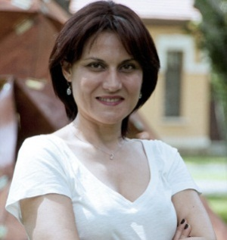Esra Arsan used to work as a print journalist for more than 10 years for several national newspapers in Istanbul, Turkey, now she teaches journalism at Istanbul Bilgi University. She is also a well-known media critic in Turkey. Her articles in which she analyses journalism practices in Turkey have been published in many newspapers, magazines, web sites and books. She holds a Ph.D degree in journalism studies specialising in political journalism. She is a former Reuters Foundation Journalism Fellow of Oxford University, UK. She has three books published: Elections in the Newspapers, European Union and Journalism, and Media Watch.

**Mr Radoslaw Markowski**, Professor at the University of Social Sciences and Humanities, Polish Academy of Sciences

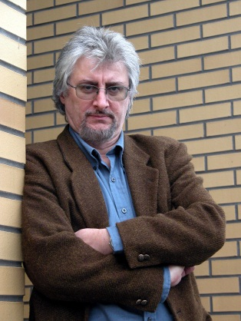Radoslaw Markowski, is a Professor of Political Science, director of the Center for the Study of Democracy at the Warsaw School of Social Sciences and Humanities and head of Comparative Politics Division at the Polish Academy of Sciences. He specialises in comparative politics, democratisation and electoral studies. Since 1995 he was PI of the Polish National Election Study. Since 1997 he is a member of the Planning Committee of the Comparative Study of Electoral Systems (CSES); Polish PI of the European Election Study of 2004 and 2009. He serves on the editorial or advisory boards of the European Journal of Political Research, Political Studies, European Union Politics, Journal of Political Science Education and Journal of Elections, Public Opinion and Parties. He has published in peer reviewed journals and edited several books mainly on electoral behaviour, party systems, democracy and democratisation. Among the main English-language publications are: Post-Communist Party Systems: Competition, Representation and Inter-party Cooperation. Cambridge UP 1999 [co-author]; Europeanizing Party Politics: Comparative Perspectives on Central and Eastern Europe. Manchester University Press 2011 [co-editor]. Visiting Professor at Duke (1994-95), Wisconsin-Madison (1997-98), Rutgers (2002-03), recurring Visiting Professor at CEU Budapest. Currently (2011-2013) Visiting Fellow and Co-Chair of Advisory Board of ERC Project Media and Democracy in Central and Eastern Europe at St. Anthony's College, University of Oxford.

**Mr Gavan Titley**,Lecturer in Media Studies, National University of Ireland

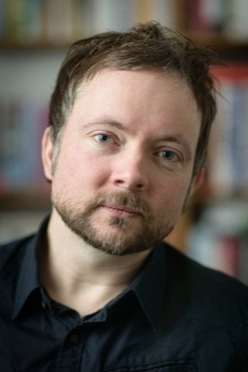Gavan Titley is Lecturer in Media Studies in the National University of Ireland, Maynooth. His research is focused on racism and public culture in Europe. His books include The Crises of Multiculturalism; Racism in a Neoliberal Age (2011, with Alana Lentin). Gavan has collaborated with the Council of Europe in youth education, policy and research for over fifteen years. He is a regular contributor to The Guardian.

**Ms Erika Mann**, Managing Director, Europe, Facebook

[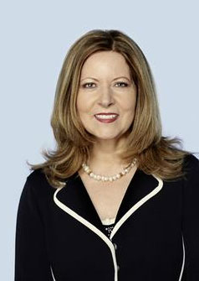](http://www.google.co.uk/url?sa=i&rct=j&q=erika+mann+facebook&source=images&cd=&cad=rja&docid=QAskQD5MOERjQM&tbnid=h3D0s5rXfgyWGM:&ved=0CAUQjRw&url=http://beuc50years.eu/topic-of-the-month/2012/february/data-protection&ei=TvgsUY66L8Gn0AWivoG4Ag&bvm=bv.42965579,d.d2k&psig=AFQjCNGFVYtVioUUszJPpH0ZFFHB2WjO_A&ust=1361988002546451)

Erika Mann heads Facebook’s policy office in Brussels and is the company's lead spokesperson for EU affairs. She is also a member of ICANN’s Board of Directors and chairs its audit committee.

Erika is best known for her work at the European Parliament, as she was a member of this institution between 1994 and 2009 elected on the list of the European Socialist Party (PES). During these years she developed an expertise in R&D, the digital economy, telecommunications, internet policy, and trade issues. She was a member of the Committee of Industry, Research and Energy, as well as of the Delegation for Relations with the United States. Born in Leipzig in 1950, Erika has a degree in social sciences from the University of Hannover.

**Mr Andrew Smith**, Legal officer, ARTICLE 19

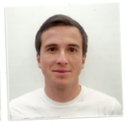Andrew Smith (BA, Law, Cambridge 2009; LL.M. University of California, Berkeley Law 2011) has worked on a variety of freedom of expression issues since joining the Law Programme as an intern in 2009. He has worked with the Commonwealth Human Rights Initiative in New Delhi on freedom of information issues, and undertaken an American Society of International Law fellowship with ARTICLE 19 East Africa, contributing to projects on the information rights of internally displaced persons and the protection of journalists from violence. Andrew’s work with the Law Programme focuses on legal reforms in East Africa and Asia and the freedom of expression rights of marginalised groups (in particular, IDPs and LGBT people), hate speech and incitement, the right to freedom of peaceful assembly, and access to information. Andrew also leads ARTICLE 19's advocacy at the UN Human Rights Council.