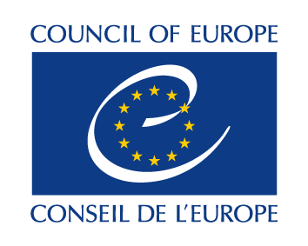  
Strasbourg, 13 February 2025 CAI-BU(2025)OJ1

**COMMITTEE ON ARTIFICIAL INTELLIGENCE**

**(CAI)**

**11th Bureau Meeting**

**19 March 2025**

10am - 4pm (CET)



**DRAFT AGENDA**



**1. Opening of the meeting**

Opening remarks by Mr Mario HERNANDEZ RAMOS, Chair of the CAI

Short introduction of Mr M. KLOTH, the Head of the Digital Development and Governance Department, and Mrs A. OVCEARENCO, the Secretary to the CAI and Head of the Digital Development Unit

**2. Adoption of the agenda**

**3. Information regarding latest developments provided by the Chair, Secretariat, and Bureau members**

**4. Information regarding the outcome of consultations regarding the future of the CAI and its new ToR**

**5. Next steps in the elaboration of HUDERIA Model**

Working document: Draft schedule of written procedure

**6. Presentation by the Secretariat regarding future HUDERIA-related activities (HUDERIA Academy and HUDERIA Platform)**

**7. Proposed update of the CAI’s website**

**8. Any other business**